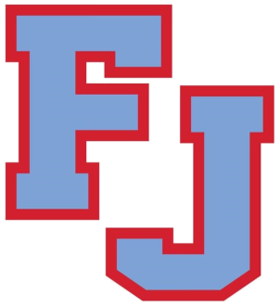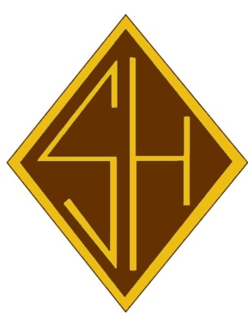
Class of 2010 10 Year Reunion
Saturday, February 29, 2020
Maggie’s Waterfront Cafe
8:00-11:00pm
$60.00 per person includes:
Buffet ● Open Bar

Please complete and return by Friday, February 21, 2020
the form below and send with checks made payable to
“The Friends of Father Judge” to
Office for Advancement and Alumni Relations,
3301 Solly Avenue, Philadelphia, PA 19136
Email for information: khuckel@fatherjudge.com
If we do not have your email, please send us a message as future correspondence will be conducted via email. Please also send along any other grad’s emails that you may have as we are missing a good deal of them.
- - - - - - - - - - - - - - - - - - - - - - - - - - - - - - - - - - - - - - - - - - - - - - - - - - - - - - - - - - - - - - - - - - - - - - - - - - - - - - - -
Name of attendee(s):___________________________________________________________
Address: ___________________________________________________ Email: _____________________________________________________
Phone number: ______________________________________________
Total amount enclosed: _______________________

□ I cannot attend, but wish to make a donation in order to support our Crusaders and Bambies!

