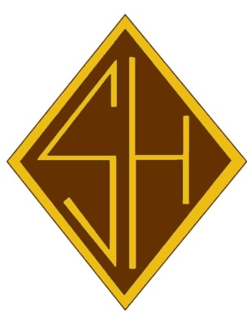
Class of 2000 20 Year Reunion
Saturday, April 4, 2020
Paddy Whacks Welsh
7:00-11:00pm
$50.00 per person includes:
Buffet ● Open Bar
All proceeds will benefit the family of fellow classmate
Denny McDaniels, who passed away in June.

Please complete and return by the form below by
Friday, March 27, 2020 and send with checks made
payable to “The Friends of Father Judge” to
Office for Advancement and Alumni Relations,
3301 Solly Avenue, Philadelphia, PA 19136
Email for information: khuckel@fatherjudge.com
If we do not have your email, please send us a message as future correspondence will be conducted via email. Please also send along any other grad’s emails that you may have as we are missing a good deal of them.
- - - - - - - - - - - - - - - - - - - - - - - - - - - - - - - - - - - - - - - - - - - - - - - - - - - - - - - - - - - - - - - - - - - - - - - - - - - - - - -Name of attendee(s):___________________________________________________________
Address: ___________________________________________________ Email: _____________________________________________________
Phone number: ______________________________________________
Total amount enclosed: _______________________

□ I cannot attend, but wish to make a donation in order to support our Crusaders and Bambies!

