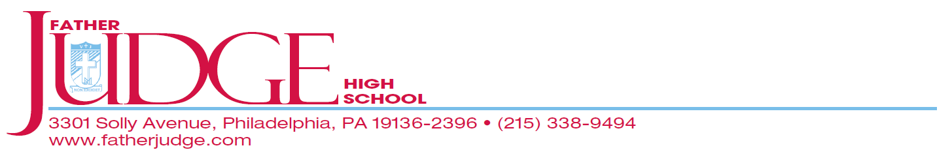
Sunday, September 11, 2022 – 1-4 pm
Ashburner Inn
Class of 1962 60th Reunion
$35.00 per person includes: Buffet ● Soda, Coffee & Tea ● Cash Bar
Please complete the form below and return by Wednesday April 20, 2022,
along with your check made payable to
“Friends of Father Judge” to
Office for Advancement and Alumni Relations,
3301 Solly Avenue, Philadelphia, PA 19136

Please use the link below if you prefer to pay electronically:
https://www.friendsoffatherjudge.com/events.html

For more information, email: khuckel@fatherjudge.com
If we do not have your email, please send us a message as future correspondence will be conducted via email. Please also send along any other grad’s emails that you may have as we are missing a good deal of them.
- - - - - - - - - - - - - - - - - - - - - - - - - - - - - - - - - - - - - - - - - - - - - - - - - - - - - - - - - - - - - -

Name of attendee(s): _________________________________________________________________________________

Address: _______________________________________________________________________________________________

Email: _____________________________________________________________Phone #:__________________________

Total enclosed: _______________________

□ I cannot attend, but wish to make a donation to the reunion in order to support my classmates. Non Excidet!

